**ANALOG ELECTRONICS LAB EC226**

**PROJECT REPORT ON “THE EFFECT OF NEGATIVE FEEDBACK ON GAIN AND BANDWIDTH OF THE AMPLIFIER”**

PRESENTED BY:

YASHWANTH G (16EC154)

SUJAY SIMHA K M (16EC148)

AIM: To study the effect of negative feedback on the gain and bandwidth of an amplifier.

THEORY:

The forward gain of the amplifier A, is given by



Where A0 = DC gain of the first order RC filter.

*W*0= 3 dB bandwidth

Considering the block diagram of an amplifier we get

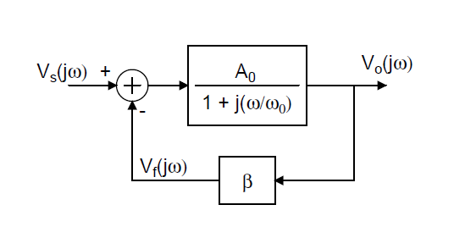

Where Vs is the input voltage

Vf is the feedback voltage

V0 is the final output voltage

For our convenience we re-write the above block diagram in another way for easy implementation.

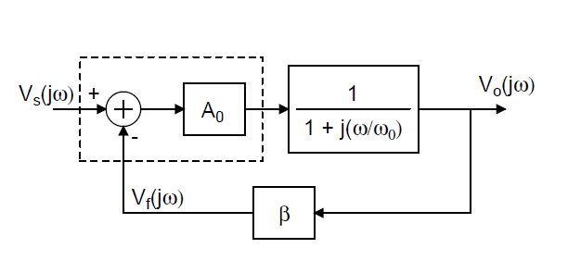

From the characteristics of op-amps we know that we can model the A0 component of this block diagram.

For the other part of the forward gain involving *w* we can use a first order RC filter

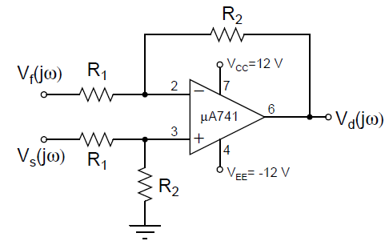

We know gain A0 is given by,

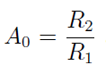

Based on this relation we can model our given circuit for any value of A0.

For the feedback network we again use an op-amp. For this case we use the op-amp as a buffer with unity gain.

This is indicated in the diagram,

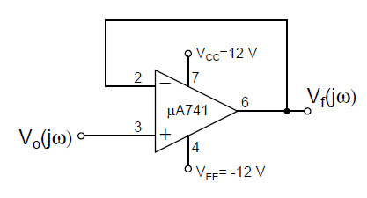

These block diagrams and circuit notations give us a clear idea on how to setup the experiment.

For all the op-amps in this experiment we are using µA741 IC.

The pin diagram for the IC is given below,

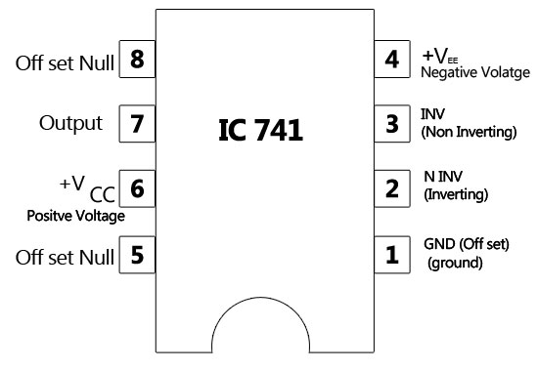

DESIGN OF CIRCUIT:

Given cut-off frequency for the RC filter is 200 Hz.

$$\frac{1}{2πRC}=f$$

fcut-off = 200 = $\frac{1}{2πRC}$

RC = $\frac{1}{ 400π}$ = 7.95 X 10-4

Taking R= 2.2 kΩ we get C = $\frac{1}{2π X 200 X 2.2 X 1000}$

C=0.36 µF

Approximate it to 0.33 µF.

This takes care of the first order RC filter portion of the circuit.

For the Amplifier A0 = 10

 therefore R2=10kΩ and R1=1kΩ

For approximated C=0.33µF the new cut-off frequency

$\frac{1}{2πRC}=f$ = $\frac{1000}{2π X 0.33 X 2.2}$ = 219.22 Hz

COMPONENTS REQUIRED:

10 kΩ resistors (X2)

1 kΩ resistors (X2)

2.2 kΩ resistor (X1)

0.33 µF capacitor (X1)

LM741 op-amp IC (X2)

DC power supply of +12 and -12 V

Function Generator

Digital Storage oscilloscope and probe wires